**Static Routing Using IPV6**

**Figure for static routing:**

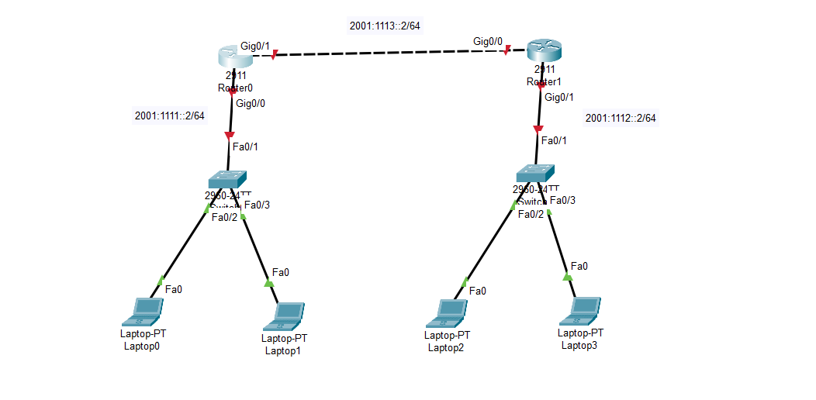

**Config the ipv6 at each router:**

**Router 0 (interface giga port 0/0)**

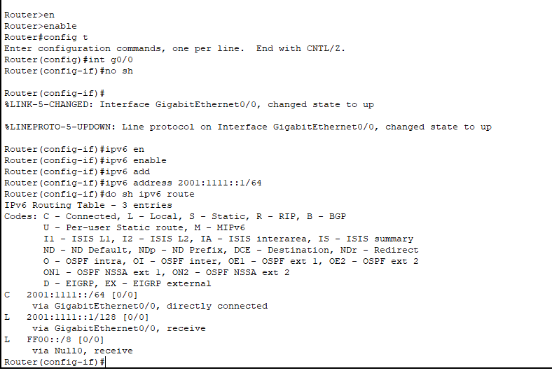

**Router 0 (interface giga port 0/1)**

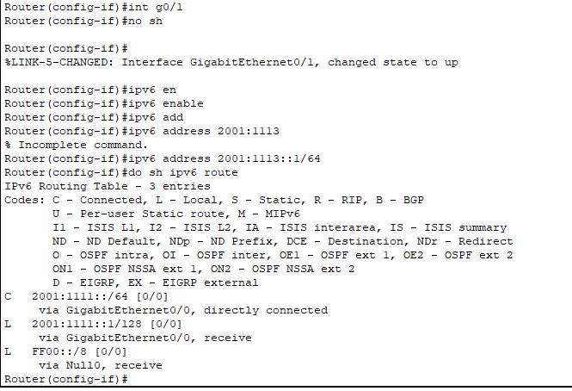

**Router 1 (interface giga port 0/0)**

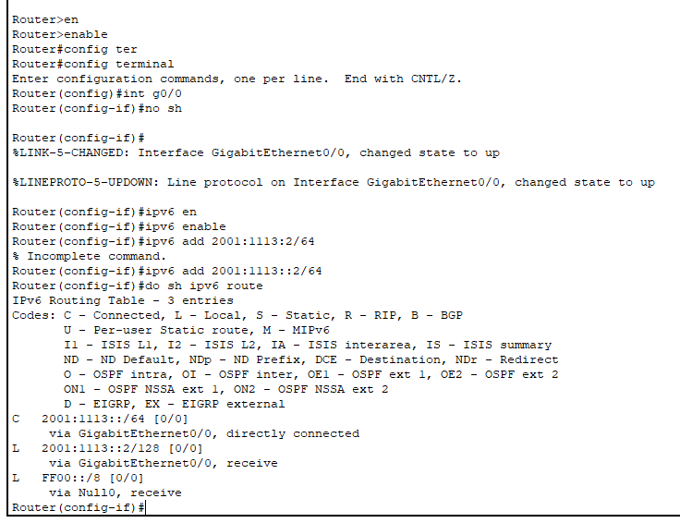

**Router 0 (interface giga port 0/1)**

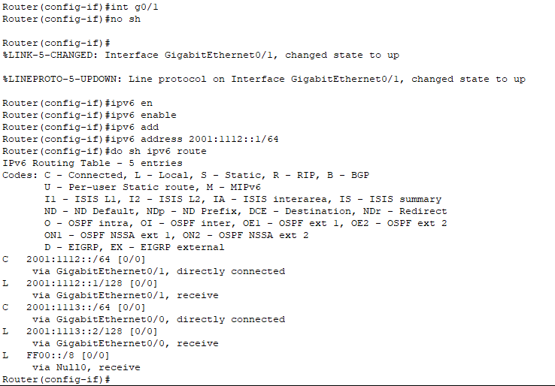

**After config the routers using ipv6:**

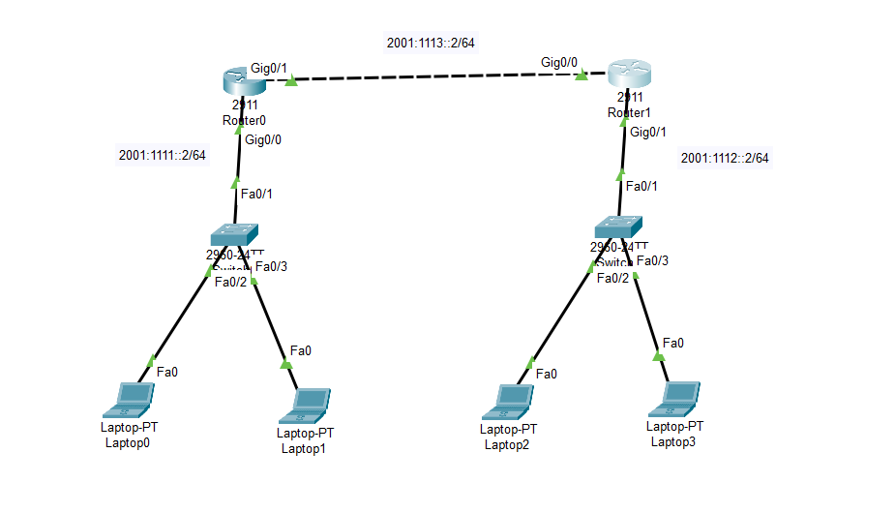

**Static Routing Config at each router:**

**Router 0:**

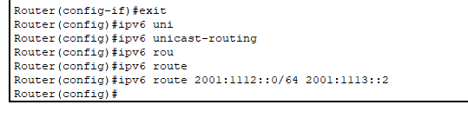

**Router 1:**

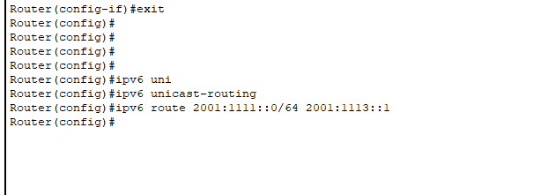

**Config IPV6 at each End-Device(Computer/Laptop):**

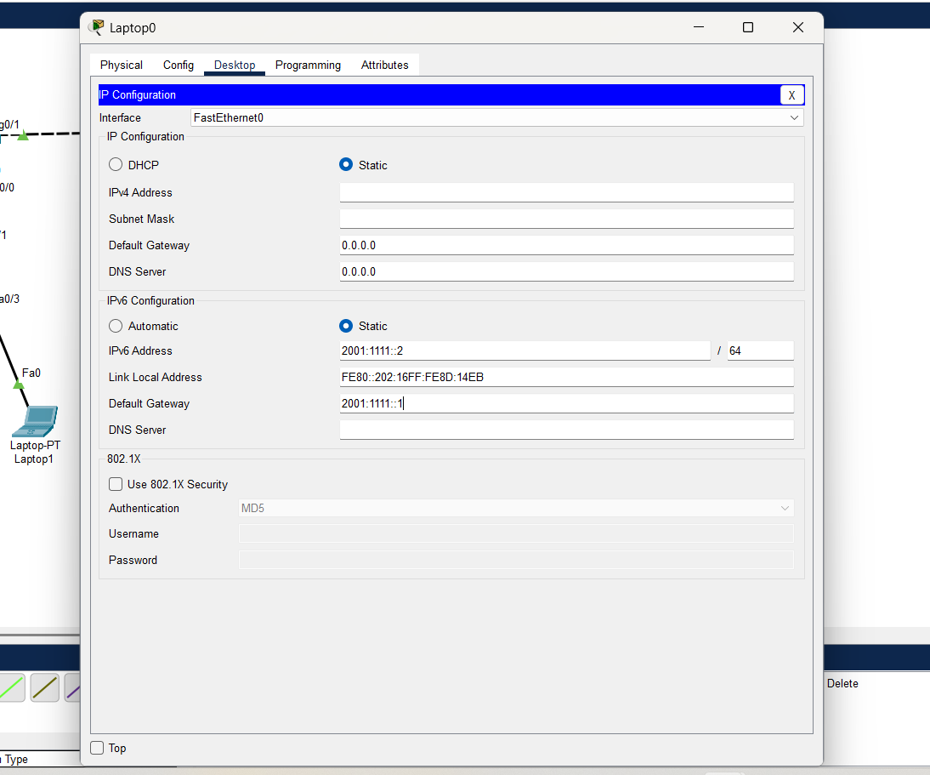

**Final OutPut:**

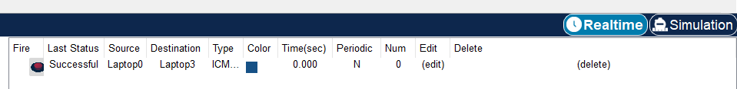

**OSPF version-3(IPV6):**

**Router 0:**

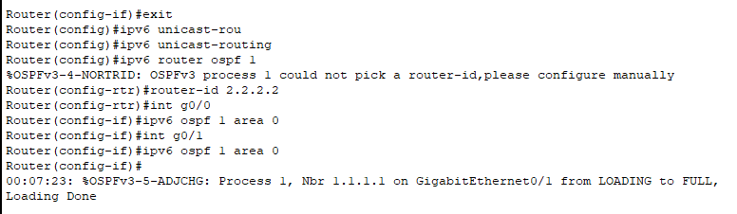

**Router 1:**

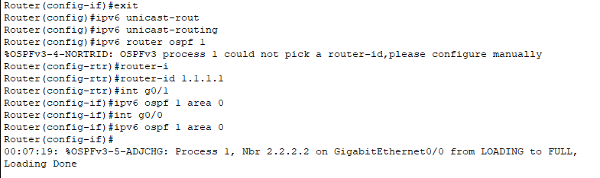

**Final OutPut:**

